Experiment 6
Lexicographically Smallest String by Swapping Two Characters Using RAPTOR

Aim
To design a flowchart using RAPTOR to find the lexicographically smallest string by swapping two characters.
Procedure
- Start the RAPTOR program.
- Input a string.
- Find the character that comes first alphabetically.
- Swap it with the first character if necessary.
- Display the resulting string.
- Stop the program.
Output
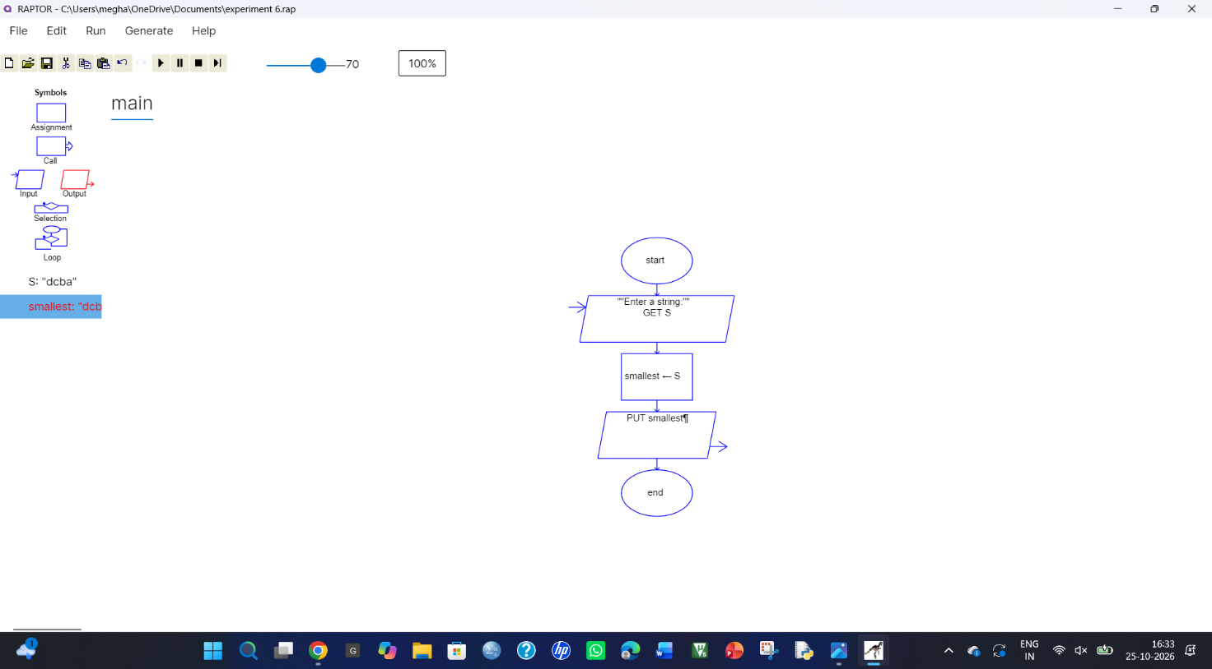
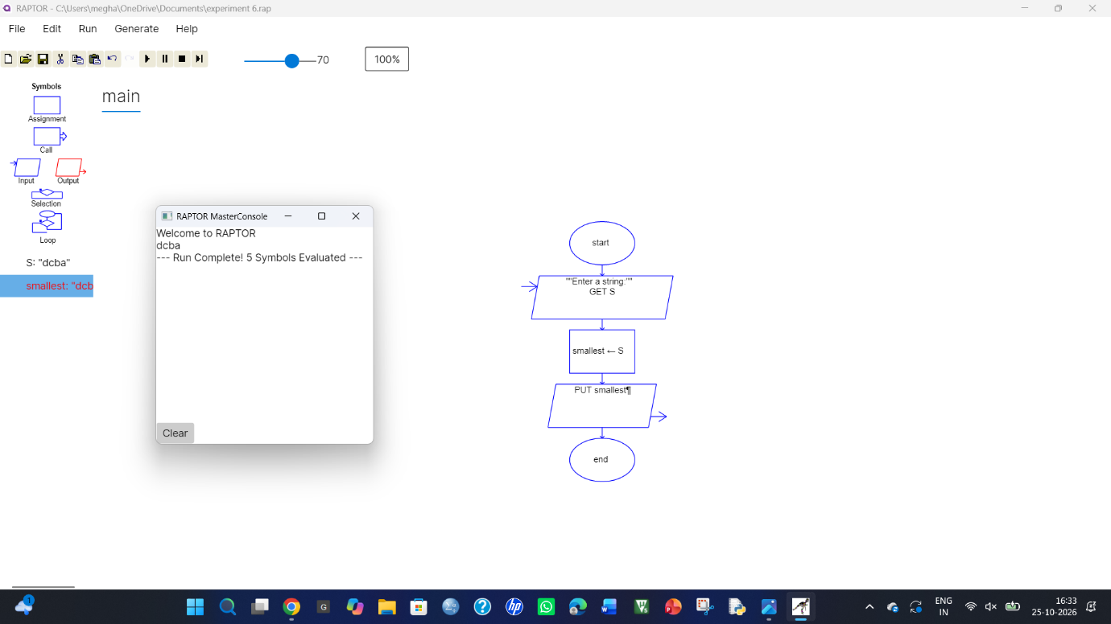
Result
The RAPTOR flowchart was designed to find the lexicographically smallest string by swapping characters.

